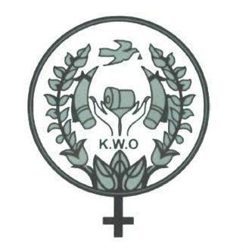
The Karen Women’s Organization Statement
In Support of Boycott of Military Companies

18 February 2020
The Karen Women’s Organization (KWO) supports calls for a boycott of Burmese military companies. We call on the people of Burma to boycott products made by military companies, and we call on foreign embassies and donors in Burma to introduce policies to ensure that their money does not reach military companies.

For decades, the Burma Army has been able to profit from businesses through their stronghold, power and influence in the sector. It is unacceptable that despite the fact that the Burmese government and Army has faced immense international scrutiny for their human rights record – they continue to earn a steady, and lucrative income.

In Karen State, the Burma Army’s illegal business activities have come at the expense of mass human rights violations including but not limited to land confiscations, bribery and threats and indiscriminate killings. From January 29th to the 11th of February, which marked Karen National Day, the Burma Army shelled more than 126 mortars into villages in Mutraw areas. Burmese soldiers were also responsible for burning down more than 40 farms belonging to innocent civilians. Last week, KWO recognized Karen National Day and took it as an opportunity to make calls for peace, unity and democracy. The reality is that there is still a long way to go as long as the Nationwide Ceasefire Agreement remains fragile and the Burma Army continues its unethical investment practices.

In September 2019, the United Nations Independent International Fact-Finding Mission on Myanmar published findings on economic interests and concluded with a call for sanctions on Burmese military companies. To date this recommendation has been ignored by the international community. International companies still do business with military companies and help finance human rights violations in our country.

We welcome the publication of the boycott list by Burma Campaign UK, which brings more visibility to the excessive involvement that the Burma Army has in corporations and services in the country. We also recognize it as an important step to make it easier for embassies, international aid departments, corporations, NGOs and individuals to refrain from purchasing goods from these companies and affiliates.

In addition to international pressure, we must apply domestic pressure on the economic interests of the Burmese military. Boycotting products made by military companies is a practical step every individual in Burma can take to reduce the income of the Burma Army.

Contact Details:

KWO Vice-Chair
Naw Alice (Burmese, Karen)
Phone number: +66 988 1432 94

KWO General Secretary
Naw K'nyaw Paw (English, Karen)
Phone number: +66 810 2955 03

